Product Community-Backend

* Database name: finaltest
* Server port: 8090
* User Authentication Api Routes-
* <http://localhost:8090/token>

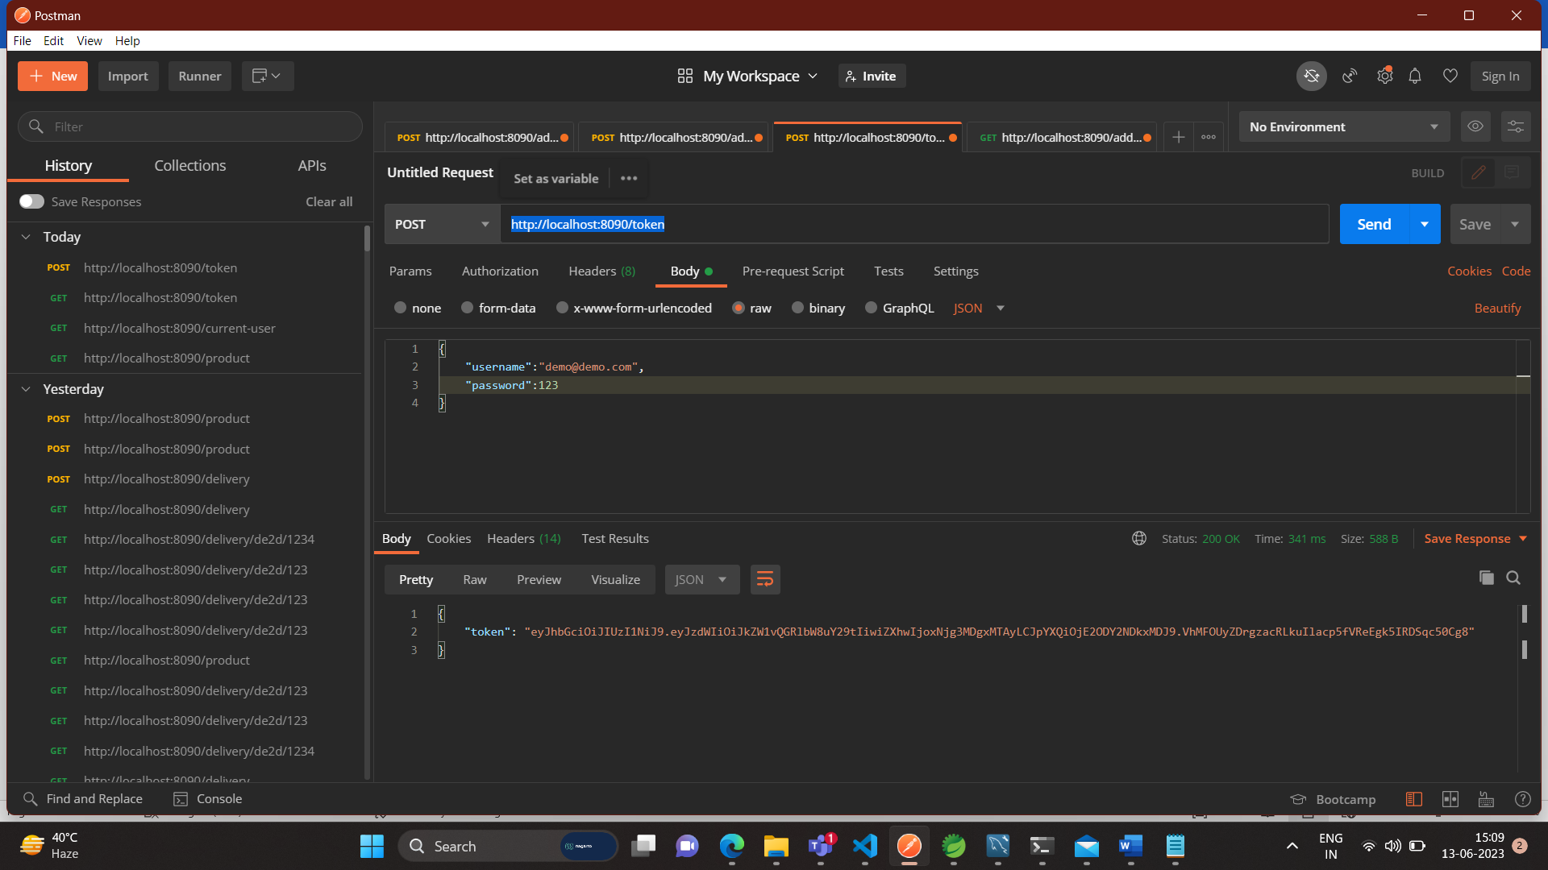

* <http://localhost:8090/current-user>

* User Registration Api

<http://localhost:8090/user/register>

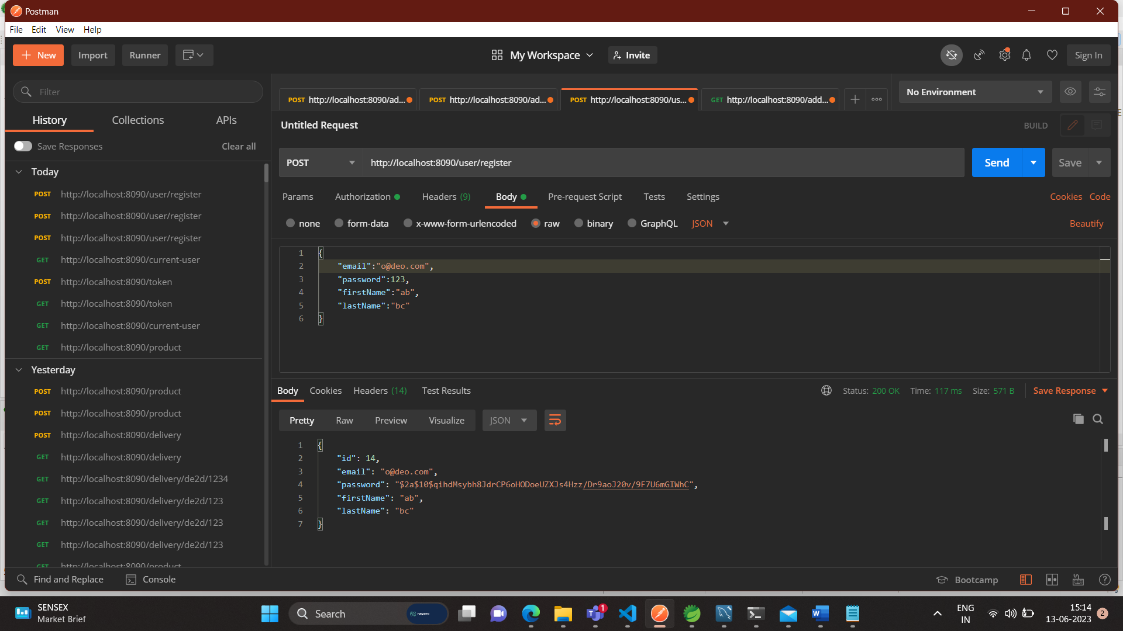

* Add Product Route

<http://localhost:8090/product>

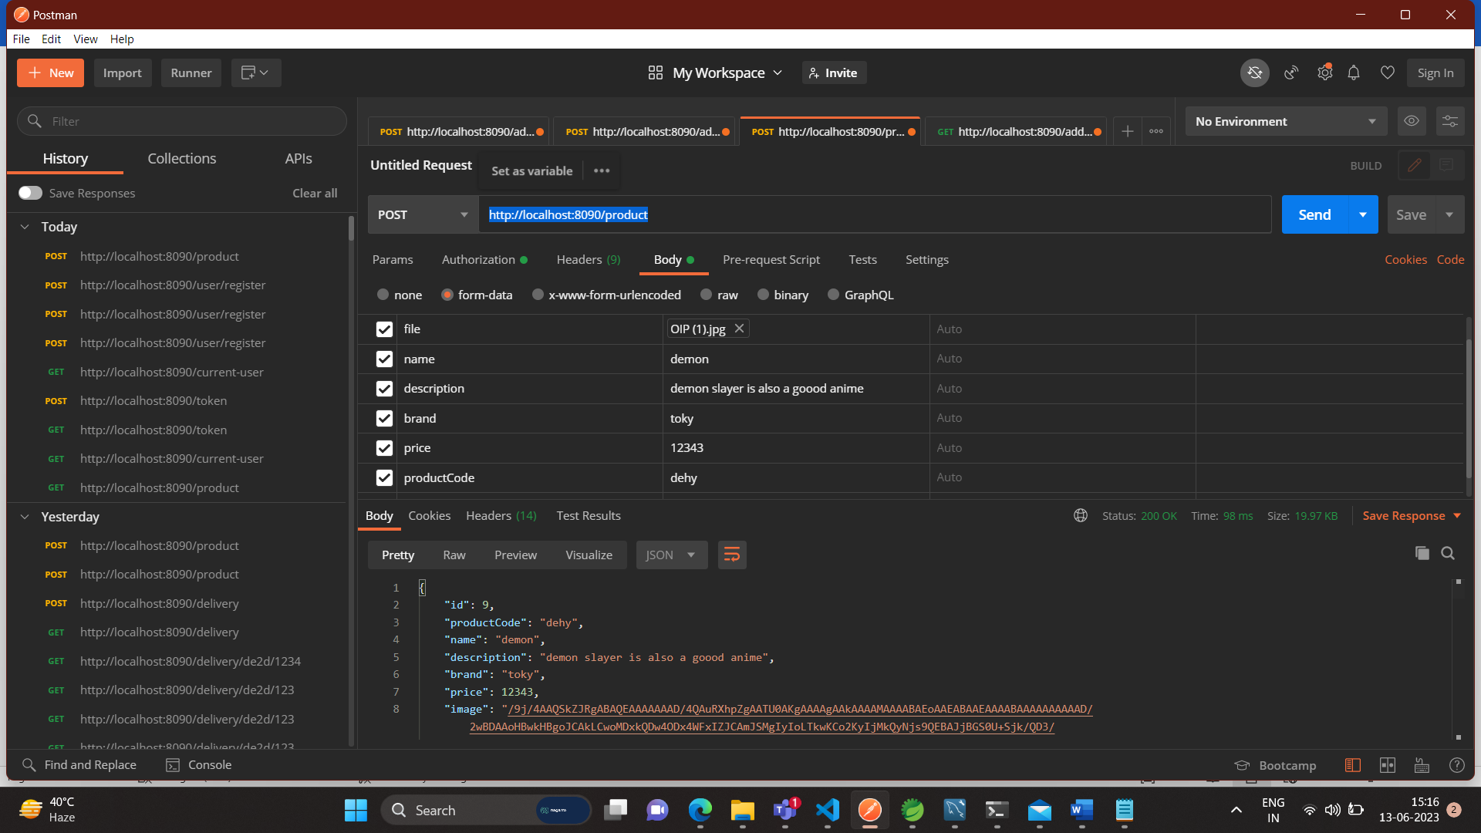

* ProductDetails Api

[http://localhost:8090/product/detail/{ProductCode}](http://localhost:8090/product/detail/%7bProductCode%7d)

* Search Api

http://localhost:8090/product/search/1/{parameter}

http://localhost:8090/product/search2/{p1}/{p2}

[http://localhost:8090/product/search/2/{p1}/{p2}/{p3}](http://localhost:8090/product/search/2/%7bp1%7d/%7bp2%7d/%7bp3%7d)

* Get Price Api

http://localhost:8090/prices

[http://localhost:8090/prices/{productCode}](http://localhost:8090/prices/%7bproductCode%7d)

* Get Servicability Api

http://localhost:8090/delivery

[http://localhost:8090/delivery/{productcode}/{pincode}](http://localhost:8090/delivery/%7bproductcode%7d/%7bpincode%7d)

Product Community-Frontend

